**Eatinerary: A food-based Itinerary  
planning app**

Applied Database Technologies (DSCI - D532)  
Project  
Report by

**Aravind Dendukuri  
NagaJahnavi Dhulipalla  
Vaibhav Piyushkumar Lodhiya**

Luddy School of Informatics  
Indiana University Bloomington

**Section 1: Project Links**

**Web URL:** <http://denarvi.pythonanywhere.com/>

**GitHub Repository: We have uploaded our entire project into the IU GitHub repository:**

<https://github.iu.edu/ardend/Eatinery_ADT>

**Section 2: Project Overview**

**Purpose:** Our project focuses on leveraging a meticulously curated dataset, comprising CSV files extracted from TripAdvisor's "things to do" page, United States zip codes page, and Yelp's provided academic data. This comprehensive data set encompasses vital information about restaurants, attractions, and zip codes, including details such as restaurant names, cuisines, review counts, star ratings, and geographical information. The data serves as a foundational resource for location-based services and recommendations.

Our scope involves developing advanced queries and insights to facilitate restaurant recommendations, cuisine matching, and attraction-based searches. Through thoughtful analysis and application, we aim to unlock the full potential of this rich dataset to enhance user experiences in the realm of location-based services.

**How It Was Built:** Our project utilizes Neo4j as database technology, and we employed tools such as Python for data scraping, CSV files for dataset creation, and Cypher queries for database operations. The database schema is designed to establish relationships between attractions, restaurants, zip codes, and primary cities, facilitating efficient querying and retrieval of information. We have used Python for data preprocessing and backend logic. Flask for the web application development and HTML, CSS and JavaScript for the front-end development.

* **Model:**
  + Developed using Flask RESTful APIs.
* **View:**
  + Views are crafted using Flask to render templates with HTML, JavaScript, CSS.
* **Controller:**
  + Controllers are implemented using Flask Web Application routers.

**Deployment Platform:**

* **PythonAnywhere:**
  + The web application is also deployed on PythonAnywhere for hosting.

**Database:**

* **Neo4j:**
  + A graph database is used to store and query data.

**Tools Used:**

* **Front End:** HTML, CSS, JavaScript
* **Back End:** Python, Flask
* **Database:** Neo4j.
* **Development Tools:** Visual Studio Code
* **Database Tools:** Neo4j BrowserTop of Form

**Data:** In our project, we've harnessed a robust dataset sourced from TripAdvisor's "things to do" page, United States zip codes page, and Yelp's academic data. This compilation, meticulously crafted without the need for scraping Yelp, is a cornerstone for location-based services and recommendations. The dataset, comprising crucial details such as restaurant names, cuisines, review counts, star ratings, and geographical information, serves as the bedrock for advanced queries. Our focus is on extracting insights related to restaurant recommendations, cuisine matching, and attraction-based searches, elevating the efficiency and precision of location-based services.

**Functionalities:**

User Authentication and Dashboard:

* User Authentication:

New users can sign up, while existing users can log in to access the dashboard.

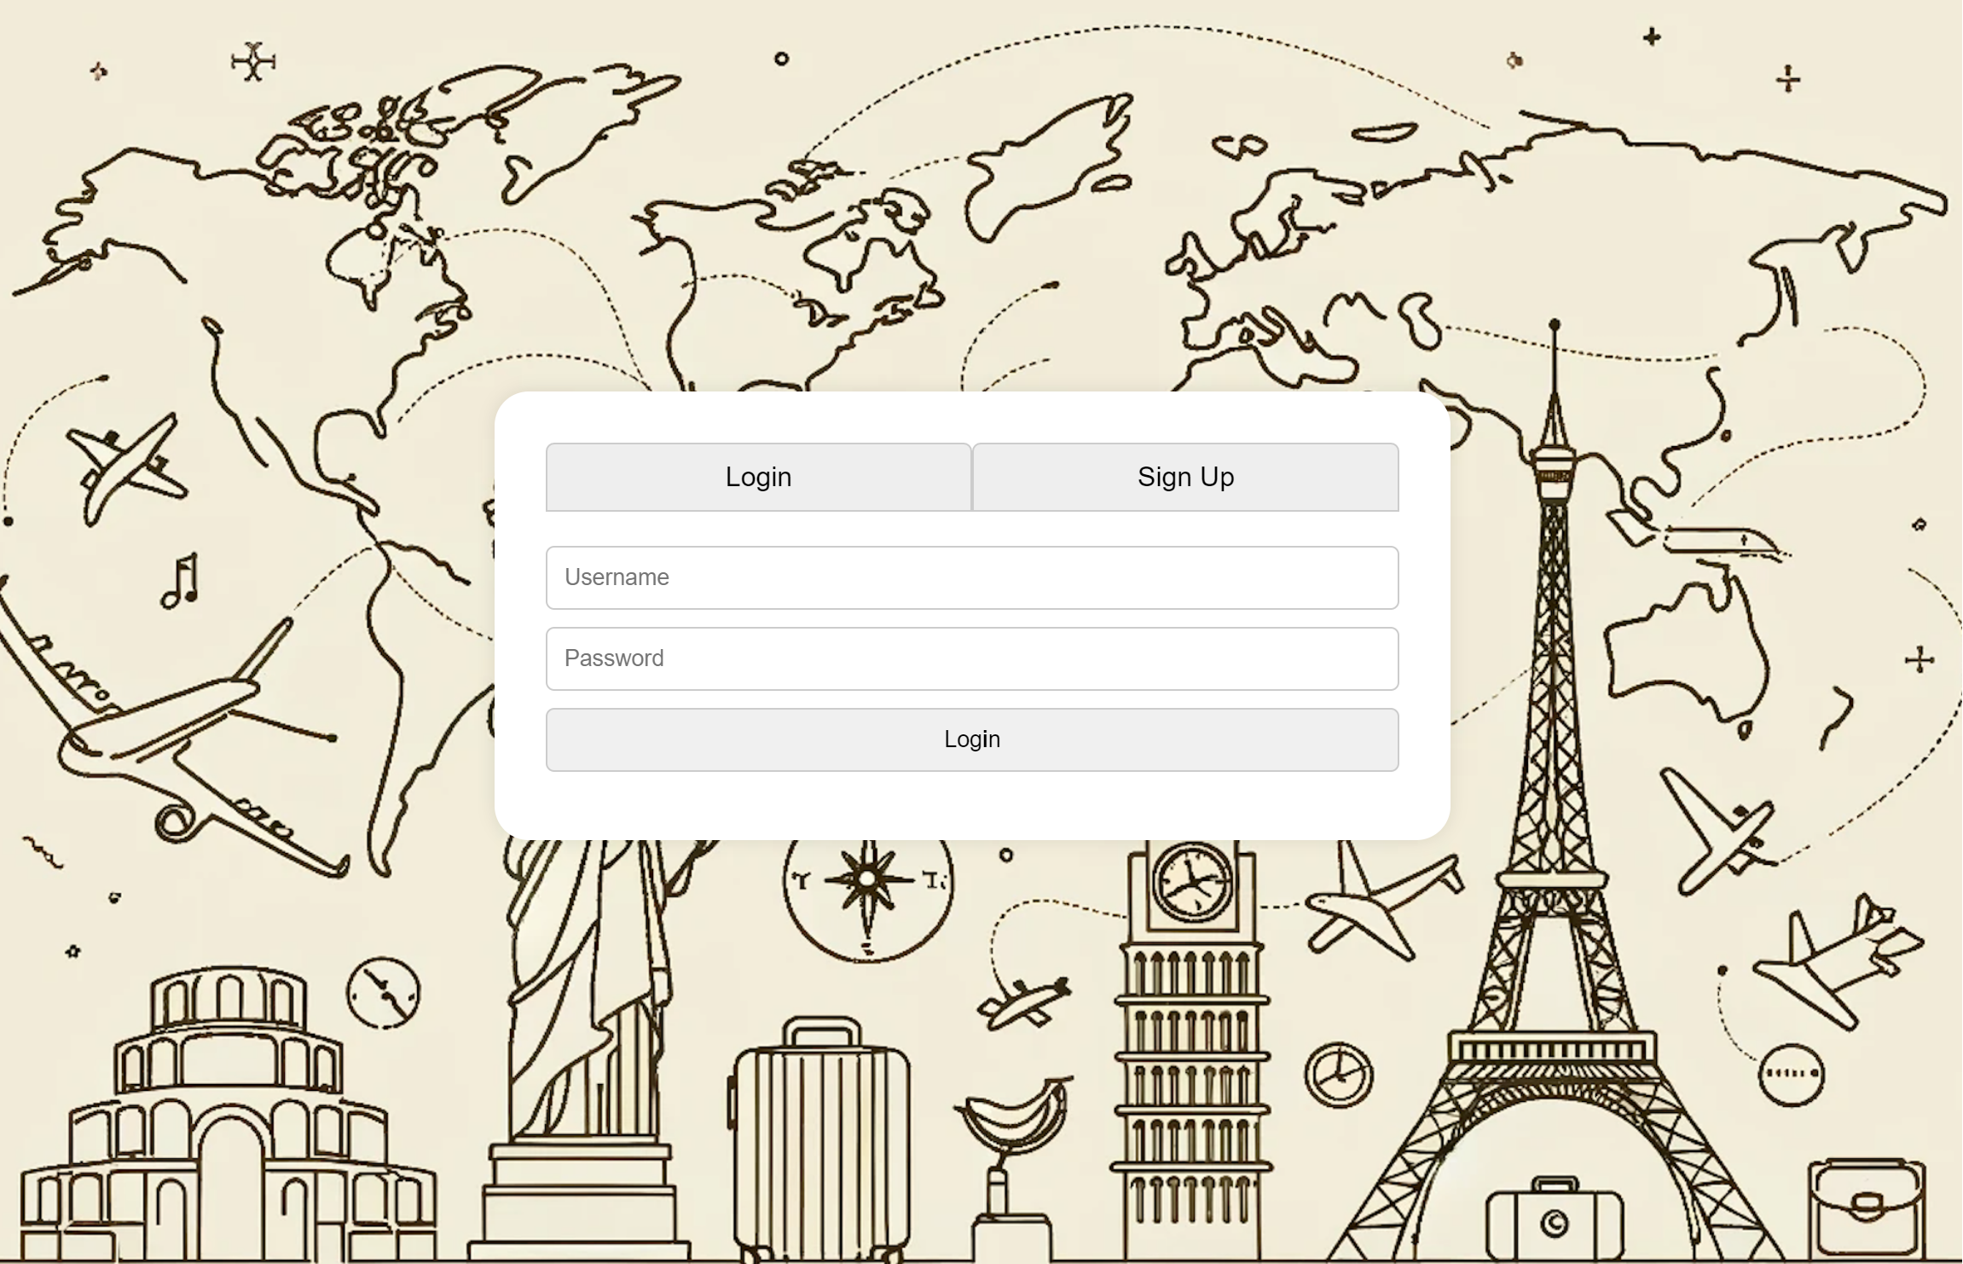

* Dashboard Options:

Once logged in, users are directed to the dashboard where they can choose from three main options:

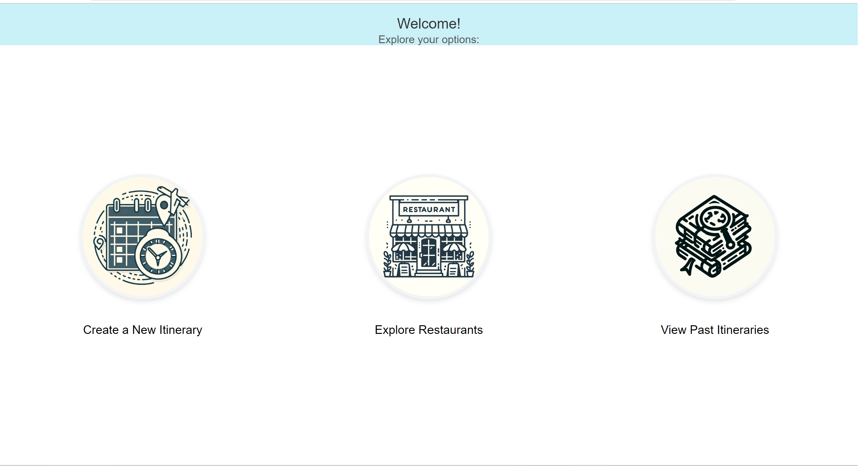

* + 1. Create New Itinerary:

Users enter the location, and the app provides a list of attractions and restaurants based on the chosen area.

* + 1. Explore Restaurants:

Users input the location and cuisine of interest, and the app recommends restaurants matching the criteria.

* + 1. View Past Itineraries:

Users can access a list of items from their previous searches.

Create New Itinerary:

* Location Input:

Users will provide the desired location for their itinerary.

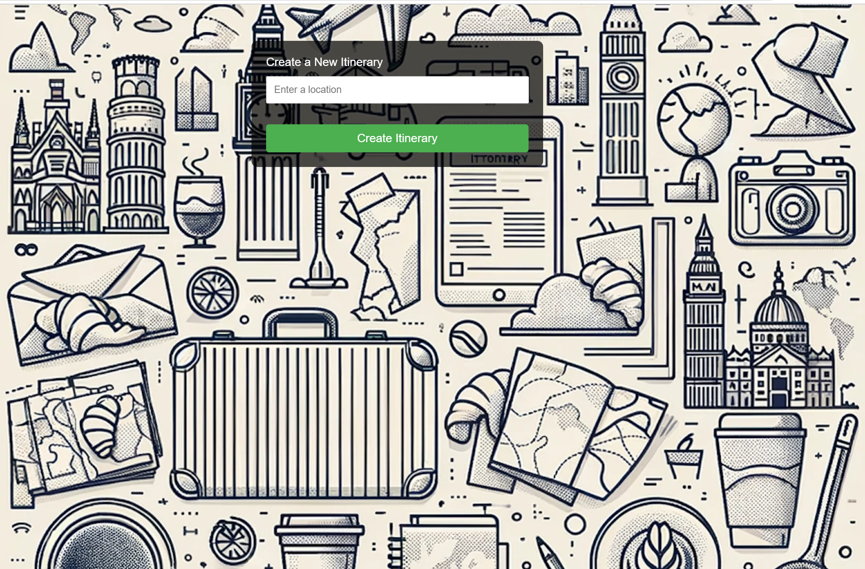

* Attractions and Restaurants List:

Once the user enters the location the app generates a list of attractions and restaurants in the specified area. For example, when we enter location as Bloomington then the app returned the below list of attractions and restaurants.

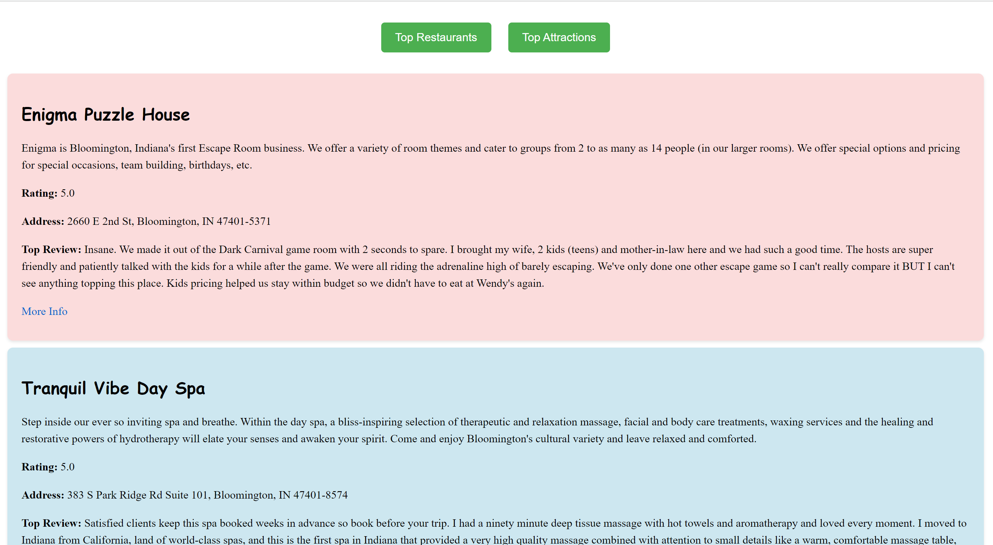

Explore Restaurants:

* Location and Cuisine Input:

Users need to enter the location and specify the cuisine they are interested in.

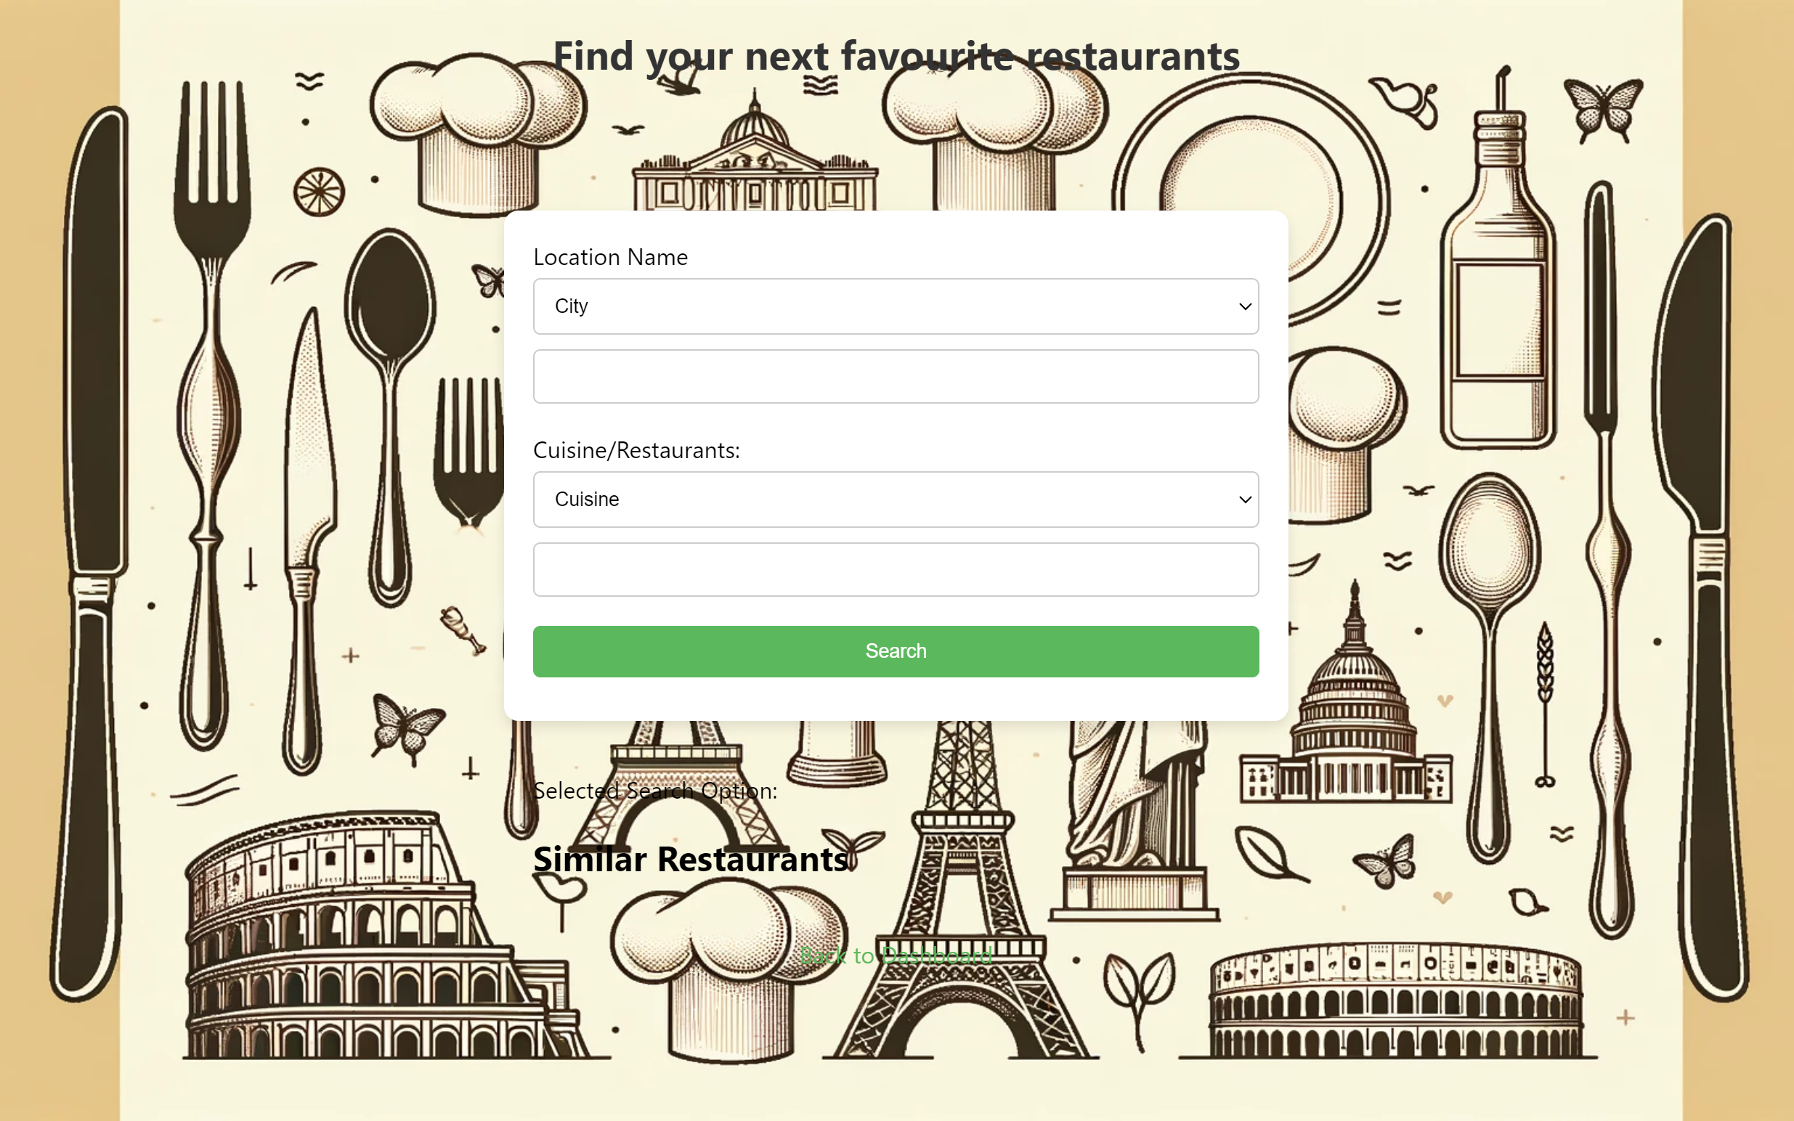

* Restaurant Recommendations:

Once the user enters their preferred location and cuisine then the app suggests restaurants based on the provided location and cuisine. For example, if we enter Indianapolis in the location and cuisine as Indian then the app generates the below data:

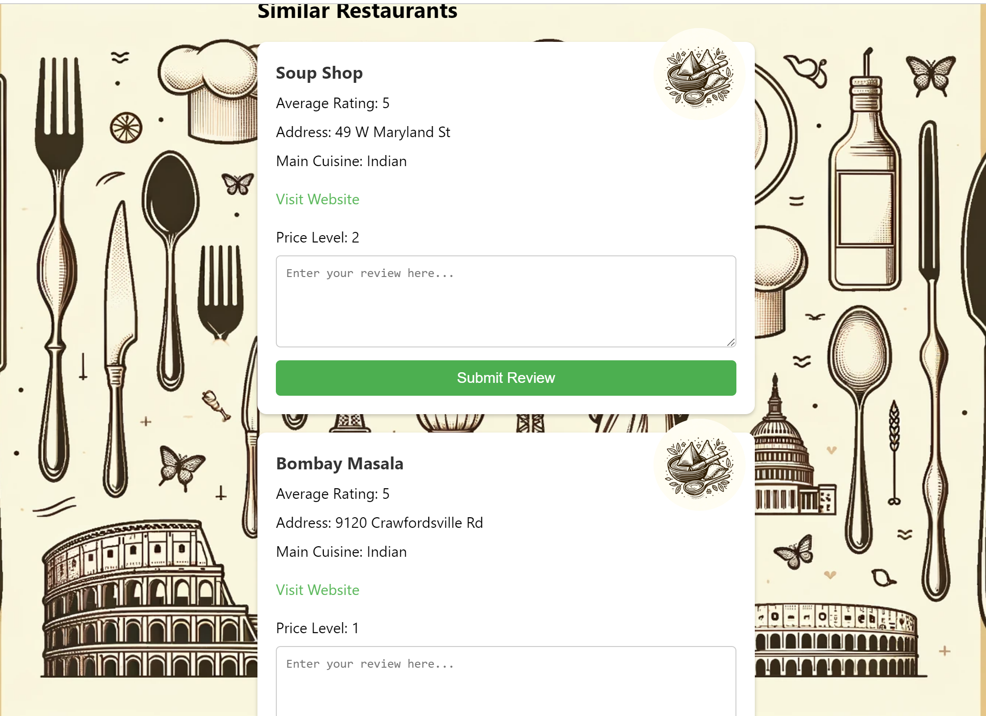 The user can also give the review for the restaurants.

Past Itinerary:

* List of Items:

Users can view and access a list of items from their previous searches.

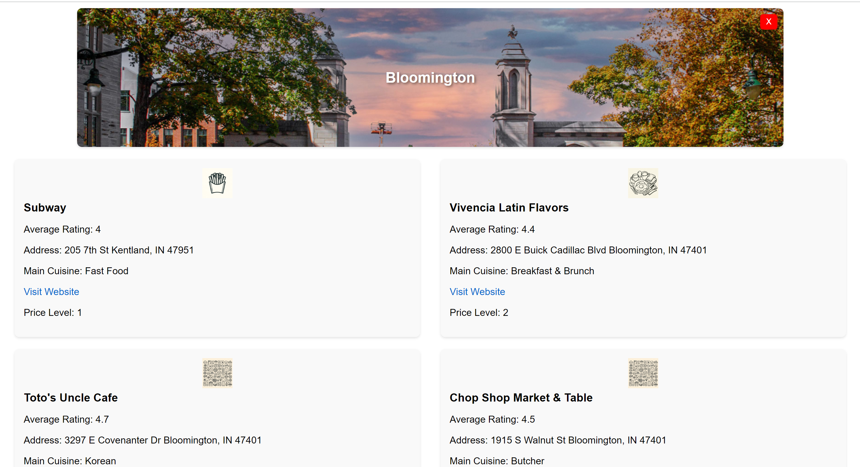

User Interaction Features:

* User Spot in Neo4j:

A special spot is created for each user in Neo4j upon signup.

* Real-time Frontend Updates:

Data brought to life on the frontend for a visual treat.

* Review Updates:

Users can share thoughts on the Restaurants page by updating reviews.

**Section 3: Issues Faced and Solutions**

| **Issue** | **Solution** |
| --- | --- |
| Data Scraping | Designed and implemented a scraping code for TripAdvisor data. |
| Database Schema Design | Collaboratively created a schema to represent entity relationships. |
| Unique Constraints Definition for Database Tables | Identified and implemented constraints to maintain data integrity. |
| Cypher Query Development | Drafted queries for functionalities like restaurant recommendations. |
| Review Updates and Deletion | Integrated functionalities for users to update reviews and perform virtual spring cleaning by deleting entire itineraries. |

**Contributions:**

| **Name** | **Task** | **Contribution** |
| --- | --- | --- |
| Aravind Dendukuri | Data Scraping, Cypher Queries, Report, Webapp deployment | Designed scraping code for TripAdvisor, wrote all Cypher queries, helped with website design, and contributed to the project report and deployed the web application. |
| Vaibhav Lodhia | Data Scraping, Database Schema, Frontend, Integration, Report | Scraped data, designed the database schema, handled frontend development and integration, and contributed to the project report. |
| NagaJahnavi Dhulipalla | Database Constraints, Queries, Frontend & Flask Code, Report | Established database constraints post data exploration, designed application-related queries, worked on frontend and Flask code, and contributed to the project report. |